Design Documentations

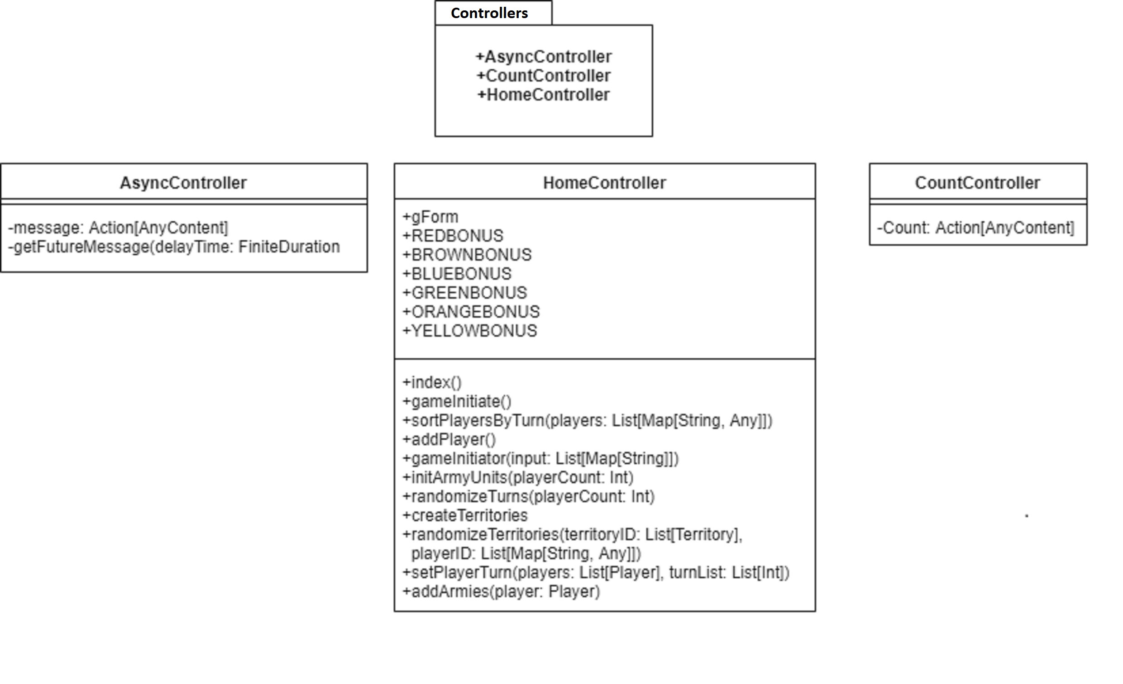

These are UML diagrams of the Controllers package and the classes contained in it. These classes create actions that handle requests and deal with other things.

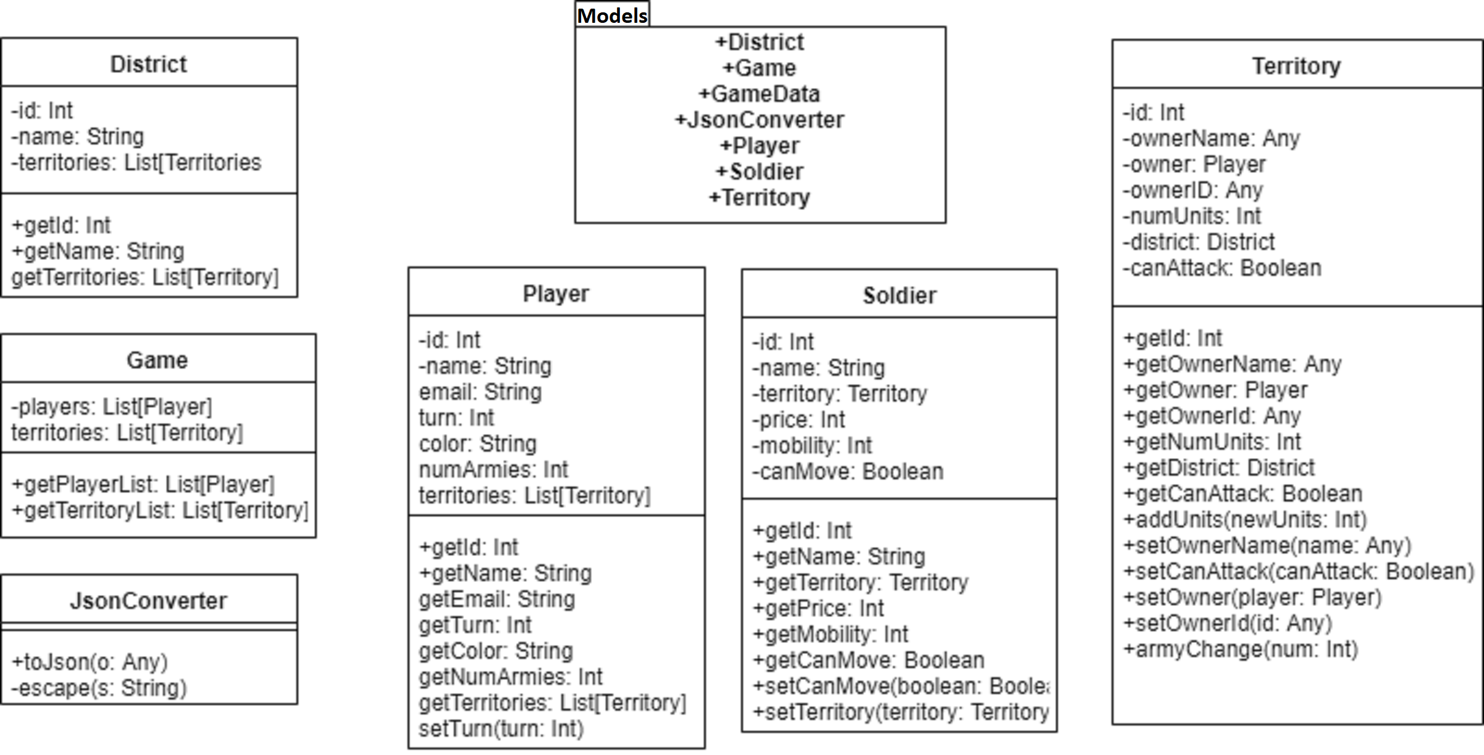

These are the UML diagrams of the Models package and the classes contained in it. These classes have the models and code of the objects that are using in the program.

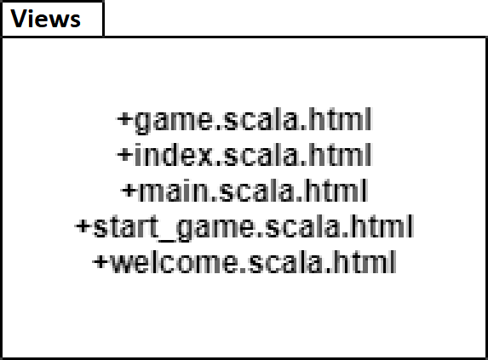

This is the UML diagram of the Views package. This package contains all the HTML code that is used in this project to have the webpage and features the way they are.

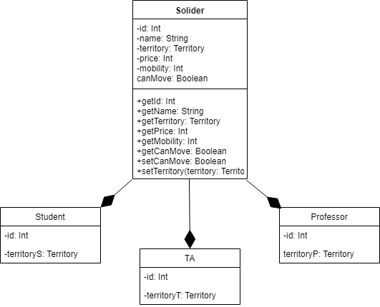

This UML diagram shows the parent-child relationships related to the Soldier class. It show the diagrams of the classes, and how the different types of soldiers, which are the Students, TAs, and Professors, are subclasses of the parent Soldier class.

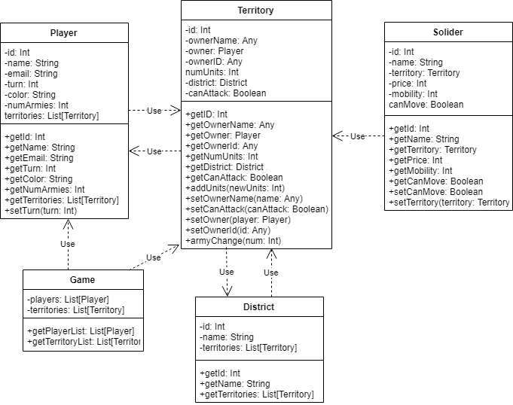

These diagrams show the dependency of the Model classes with each other. The arrows mean that the class the arrow starts on uses aspects of the class that the arrow is pointing at. For example, the Player and Territory classes both depend on each other, while Soldier depends on Territory, but Territory doesn’t depend on District, and so on.